1. 8-QUEEN PROBLEM
Aim
To write a Python program to solve the 8-Queen problem using Backtracking.
Objective
To place 8 queens on an 8×8 chessboard so that no two queens attack each other.
Algorithm
- Create an empty 8×8 chessboard.
- Start from the first column.
- Place a queen in a safe row.
- Check rows and diagonals for safety.
- If safe, move to the next column.
- If no safe position exists, backtrack.
- Print the solution.
Python code:
N = 8

board = [[0] * N for _ in range(N)]

row = [False] * N
diag1 = [False] * (2 * N - 1)
diag2 = [False] * (2 * N - 1)

def solve(col):
if col >= N:
return True

for r in range(N):
if not row[r] and not diag1[r + col] and not diag2[r - col + N - 1]:

board[r][col] = 1
row[r] = True
diag1[r + col] = True
diag2[r - col + N - 1] = True

if solve(col + 1):
return True

board[r][col] = 0
row[r] = False
diag1[r + col] = False
diag2[r - col + N - 1] = False

return False

if solve(0):
print("Solution Found:\n")
for i in board:
print(i)
else:
print("No Solution")

Flowchart:
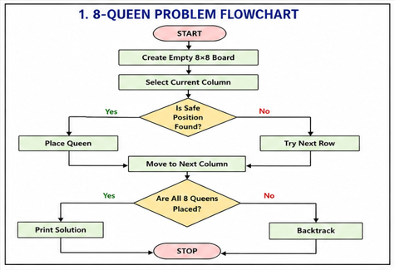
Output
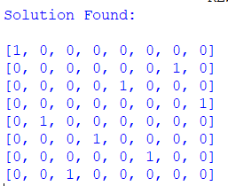
Result
Thus, the Python program to solve the 8-Queen problem was executed successfully.
Conclusion
The 8-Queen problem successfully solved

